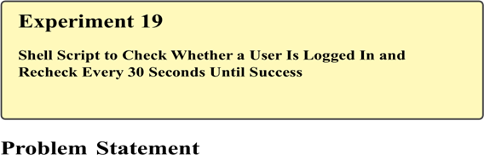
In multi-user Linux environments, system administrators and security professionals often need to monitor user login status—for example, to detect authorized access, synchronize tasks with user activity, or trigger actions only after a specific user logs in. Automating this monitoring avoids continuous manual checking and ensures timely response.
The problem is to write a shell script that checks whether a specified user is logged in to the system and continues checking at regular intervals (every 30 seconds) until the user logs in, demonstrating looping, conditional checks, and time-based execution in Bash scripting.

Theory

User Login Monitoring in Linux
Linux provides commands such as who, users, and w to display information about currently logged-in users. By filtering the output of these commands, scripts can determine whether a particular user is active.

Looping with Delay
A while loop combined with the sleep command enables periodic checks at fixed intervals. This approach is widely used in monitoring scripts, cron jobs, and security checks.

Commands Used
who | Display logged-in users
grep | Search for a specific user
while | Loop until condition is met
sleep | Pause execution for a fixed time
echo | Display messages

Procedure

A. Writing the Shell Script
- Open the terminal.
- Create a script file:
nano check_login.sh
- Enter the following script:
#!/bin/bash

echo "Enter the username to check:" read username
while true do
if who | grep -w "$username" > /dev/null
then
echo "User $username is now logged in." break else
echo "User $username is not logged in. Checking again in 30 seconds..." sleep 30 fi done
- Save and exit the editor.
- Make the script executable:
chmod +x check_login.sh

B. Executing the Script
- Run the script:
./check_login.sh
- Enter a valid username when prompted.
Log in as that user (from another terminal or system) to observe script behavior.
